* **Lab Task 6:**

Find all planes that do not have an assigned route.

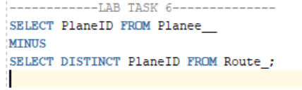

OUTPUT:

